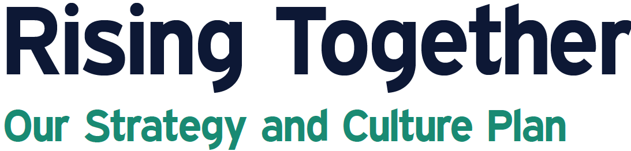
Progress Update

In 2022, the Rise team set three strategic goals to strengthen our impact towards ending poverty through economic and social mobility. In this first phase of actioning our goals (Years 1 and 2), Rise focused on aligning our culture, staffing, services and data collection towards the stages of transformation and strengthening our foundations as an organization.

Strategic Goal | Highlights of Achievements
Targeted Service Delivery and Impact  We will strengthen alignment of our service model to the stages of transformation, build our organizational data, and strengthen our impact. | - Our Theory of Change describes our service model, including who Rise serves, how services align with the stages of stabilization, mobility and empowerment, and our expected outcomes and impact.  - Key messages are helping people understand the stages of transformation.  - Our data collection and management system is reconfigured to capture client progress through the stages of transformation.
Strengthen Foundations (Leadership, Workforce, and Culture), Operations, and Governance  We will plan and act to build our team, expand our capacities, strengthen our operations and governance, and ensure Rise’s sustainability. | - Our roles and job descriptions are more clearly defined, including how they contribute to stabilization and empowerment work. This enables staff to take leadership in different areas of work.  - A new performance management matrix, revised tools (questionnaire, reflective practice), and regular performance management meetings offer opportunities for professional growth.  - A Welcome, Culture, Strategy onboarding package is ready for launch. It will foster Rise culture among volunteers, staff, and board members and strengthen Rise as a learning institution.  - An improved volunteer strategy is in development to boost volunteer recruitment and fund development.  - Our financial management system is strengthened.  - An annual governance calendar supports Board planning and work.
Data Informed Decision Making  We will use our strengthened service model, data, and foundational capacities to improve outcomes for the people we serve. | - Our First Annual Impact Report based on our strengthened data management system communicates our impact for 2024.  - Work is ongoing to map data collection against our Theory of Change and to strengthen communication about the impact of our work.
These achievements pave the way for our next phase of actioning Rise’s strategic goals. Our next priorities are to more deeply involve staff in our Strategy and Culture plan, grow staff development opportunities, continue to improve our impact measurement tools and make greater use of them, and launch our volunteer and ambassador strategy. As Rise’s capacities and impact grow, so will our focus on influencing systems change towards ending poverty.

Rise Calgary 2024 Impacts

In 2024, Rise Calgary is:
✓ | MEETING GROWING DEMANDS | Over 20,000 Interactions logged, about 84 interactions per day, a 41% increase over last period.
✓ | SUPPORTING HOUSING STABILITY | 584 Basic Needs Fund applications completed to assist customers with housing-related emergencies.
✓ | IMPROVING FINANCIAL SITUATIONS | $2,129,396 gained to 980 customers through taxes and benefits programs.

From Scarcity to Strength:
- Stabilization: Rise Calgary alleviated urgent financial crises for numerous individuals and families ensuring Calgarians have food, shelter, clothing and income through activities like filing taxes and accessing benefits and/or advocating for income.
- Mobility: Rise Calgary helps customers build and maintain stability through our coaching approach to moving out of poverty.
- Empowerment: Rise Calgary strategizes with individuals to build financial confidence and new financial assets.

By The Numbers:
Stabilization | Mobility | Empowerment
7093 visits provided crucial food support, helping families stay strong. | 563 career and employment visits, fueling pathways to new opportunities. | 57 customers empowered to take control of their financial futures through expert coaching.
13,531 visits ensured housing and basic needs were met. | 198 hours spent with 32 unique customers on Mobility Coaching | 12 community engagements for the Talking Taxes program empowering 787 unique participants in their communities.
386 completed years of taxes filed in Talking Taxes. | 879 coaching interactions, driving progress and unlocking potential. | 737 community connections built, fostering support, collaboration, and growth.



